# TITLE:

**A TECHNICAL REPORT**

**ON**

**STUDENT INDUSTRIAL WORK EXPERIENCE SCHEME(SIWES)**

**UNDERTAKEN AT**

**TALOSMART LIMITED**

**BY**

**AKANDE OLUMIDE JONATHAN**

**MATRIC NO: 222458**

**SUBMITTED TO THE DEPARTMENT OF COMPUTER SCIENCE,**

**FACULTY OF SCIENCE,**

**UNIVERSITY OF IBADAN,**

**IBADAN.**

**IN PARTIAL FULFILLMENT OF THE REQUIREMENTS FOR THE AWARD OF BACHELOR OF SCIENCE (B.sc.) DEGREE**

**IN COMPUTER SCIENCE.**

**October, 2023.**

Department of Computer Science,

University of Ibadan,

Ibadan, Oyo State.

10th October, 2023.

The Director,

Industrial Training Coordinating Centre,

University of Ibadan,

Ibadan, Oyo State.

Dear Sir,

# LETTER OF SUBMISSION OF SIWES REPORT

**I, AKANDE OLUMIDE JONATHAN** with matriculation number **222458** having completed my 3 months Students Industrial Work Experience Scheme (SIWES) training being a requirement for completion of my BSc. In Computer Science, hereby write to present the technical report of my Industrial training undertaken at Talosmart Limited.

Thank you for your anticipated consideration and approval of my report.

Yours faithfully,

AKANDE OLUMIDE JONATHAN

# DEDICATION

This report is dedicated to my family for the extraordinary support and love I've received from my family. While I won't mention names, I want to express my deep gratitude to each member of my family for their unwavering presence in my life.

The bond we share is invaluable, and it has shaped me in profound ways. Your support during the challenges and celebrations alike has been my source of strength. Your sacrifices and selflessness have not gone unnoticed, and I am profoundly thankful for your enduring love.

In the tapestry of my life, my family is the most vibrant and essential thread. This report serves as a tribute to the profound impact you've had on my journey, and I look forward to creating more cherished memories together in the future.

# ACKNOWLEGDEMENT

I humbly express my profound gratitude to God Almighty for His constant guidance and grace in my life.

I want to extend my heartfelt gratitude to the dedicated staff of **Talosmart**. Your commitment, hard work, and exceptional service have made a significant impact, and I appreciate all that you do. Thank you for your professionalism and dedication to excellence.

My regards to my dear Uncle, **Mr. Olusola Binuyo**, who has been a constant source of wisdom, support, and financial assistance during my SIWES (Students Industrial Work Experience Scheme). I wish you continued blessings from God Almighty.

# TABLE OF CONTENTS

TITLE: 1

LETTER OF SUBMISSION OF SIWES REPORT 2

DEDICATION 3

ACKNOWLEGDEMENT 4

TABLE OF CONTENTS 5

ABSTRACT 6

INTRODUCTION 7

INTRODUCTION TO SIWES 7

BACKGROUND AND HISTORY OF SIWES 7

OBJECTIVES OF SIWES 8

ADVANTAGES OF STUDENT INDUSTRIAL TRAINING 8

INTRODUCTION TO TALOSMART LIMITED 10

COMPANY OVERVIEW 10

SERVICES PROVIDED BY TALOSMART 10

MY ROLE AT TALOSMART 10

1 COMPREHENSIVE OVERVIEW OF MY ACCOMPLISHMENTS AT TALOSMART 11

1.1 EXPANDING HORIZONS: MY JOURNEY IN WEB DEVELOPMENT AND CMS MASTERY DURING INDUSTRIAL TRAINING 11

1.2 FIRST, WHAT IS WEB DEVELOPMENT 11

1.3 CONTENT MANAGEMENT SYSTEMS EMPLOYED FOR WEB DEVELOPMENT DURING MY SIWES AT TALOSMART 12

2 WORK DONE WITH LIFETECH OCMS 13

2.1 OVERVIEW OF LIFETECH OCMS 13

2.2 FEATURES 13

2.3 MY APPLICATION OF LIFETECH OCMS 13

# ABSTRACT

The Student Industrial Work Experience Scheme, initiated by the Federal Government of Nigeria, was designed with the goal of providing students from higher education institutions with the opportunity to gain practical experience and industrial skills relevant to their chosen field of study. Additionally, the program aimed to equip students with the technical competencies needed for their future careers upon graduation.

This technical report is a reflection of the knowledge and experience I acquired during my three-month industrial training at Talosmart Limited. Within this report, I detail my journey of learning content management systems for web development, including LifeTech OCMS, as well as gaining proficiency in Wordpress and Dropazz. These skills have significantly broadened my expertise within the field of computer science, my chosen area of study. It also delves into the activities I undertook and the valuable experiences I gained during this training period. Additionally, I address the challenges encountered and provide suggestions to enhance the program.

# INTRODUCTION

## INTRODUCTION TO SIWES

The Student Industrial Work Experience Scheme (SIWES) is a program jointly administered by the Industrial Training Fund (ITF) and the National University Commission (NUC). Its primary objective is to offer students across diverse academic departments the opportunity to gain practical experience, thereby bridging the divide between theoretical knowledge and practical application.

This initiative operates as a collaborative effort involving the ITF, students, and industries. Its overarching goal is to enhance students' proficiency and comprehension in their respective fields, fostering a deeper understanding of real-world applications within the realm of physical planning and other related disciplines.

### BACKGROUND AND HISTORY OF SIWES

The 1988 Industrial Training Fund National Conference, held in Jos, mandated all collaborating agencies, including NCCE, NBTE, and NUC, to create job specifications for degree programs, including the Student Industrial Work Experience Scheme (SIWES). At that time, these job specifications were intended to provide guidance to both industrialists and institutional supervisors when placing students in industrial settings. The goal was to ensure students received the minimum required industrial exposure to prepare them for future employment.

Recognizing the importance of job specifications in SIWES, the National University Commission (NUC) began working on this initiative shortly after the 1988 resolution. However, it wasn't until January 1996, during a 3-day national workshop in Jos, that job specifications were developed for all 71 programs that incorporated industrial attachment components in their minimum academic standard documents.

Nine panels, each led by a senior academic staff member, were formed to address the 46 programs involved. During two-day meetings, these panels meticulously drafted job specifications. Subsequently, a one-day meeting was convened to present five invited papers and establish the procedure, content, and format for job specification documents.

The initial draft of this document was circulated to universities, ITF industries, and professional bodies associated with the Scheme for their input and feedback. The panel then considered and incorporated relevant comments, resulting in the final job specification documents, organized into four parts: Introduction, Objectives, Physiology, and Job Schedule.

### OBJECTIVES OF SIWES

Here are the primary goals and objectives of SIWES:

1. To create an opportunity for Nigerian university students to gain practical industrial skills and hands-on experience relevant to their field of study.
2. To facilitate a smoother transition from the university to the professional workforce, thereby improving competitiveness for future job placements.
3. To familiarize students with work methodologies and the operation of equipment and machinery that may not be accessible within the university setting.
4. To equip students with the skills and readiness required for the work scenarios they are expected to encounter upon graduation.
5. To engage and enhance employer participation in the complete educational process aimed at preparing university graduates for employment within the industry.
6. To afford students the chance to apply their theoretical knowledge in practical work settings, thereby narrowing the divide between university coursework and real-world application.
7. To instill a sense of professionalism, workplace ethics, and responsibility in students, preparing them for a successful career.
8. To foster collaboration and networking between educational institutions and industries, promoting mutual benefit and knowledge exchange.
9. To enhance students' problem-solving abilities, adaptability, and critical thinking skills by exposing them to real-world challenges and scenarios.

### ADVANTAGES OF STUDENT INDUSTRIAL TRAINING

Industrial training offers a wide range of benefits to students, enhancing their educational experience and preparing them for future careers. Here are some key benefits of industrial training to students:

1. **Practical Experience**: Industrial training provides students with hands-on experience in a real-world work environment. This practical exposure helps students apply theoretical knowledge acquired in the classroom to actual work situations.
2. **Skill Development**: During industrial training, students have the opportunity to develop and refine various skills, including technical, communication, problem-solving, and interpersonal skills. These skills are valuable for their future careers.
3. **Industry Insights**: Students gain valuable insights into industry practices, trends, and technologies. This exposure helps them stay updated with the latest developments in their field of study.
4. **Networking Opportunities**: Industrial training allows students to build a professional network. They can connect with experienced professionals, mentors, and potential future employers, which can be beneficial for job placement.
5. **Resume Enhancement**: The experience gained during industrial training enhances a student's resume. It demonstrates to prospective employers that the student has practical experience and is well-prepared for the workforce.
6. **Increased Employability**: Completing industrial training makes students more attractive to employers. Many companies prefer to hire candidates with prior industry experience, and industrial training provides this advantage.
7. **Career Clarity**: Students often gain clarity about their career goals and preferences during industrial training. They can explore different roles and industries to determine what aligns best with their interests and strengths
8. **Professionalism**: Industrial training helps students develop a professional attitude and work ethic. They learn about workplace etiquette, punctuality, and how to collaborate effectively with colleagues.
9. **Problem-Solving Skills**: Students encounter real-world challenges during industrial training, which hones their problem-solving skills. They learn to identify issues and find practical solutions.
10. **Applying Academic Knowledge**: Industrial training allows students to see how their academic knowledge is applied in practical settings, reinforcing their understanding of their field of study.

In summary, industrial training is a valuable component of education that offers students numerous benefits, from practical experience and skill development to increased employability and personal growth. It plays a crucial role in preparing students for successful careers in their chosen fields.

## INTRODUCTION TO TALOSMART LIMITED

### COMPANY OVERVIEW

Many startups can’t afford a professional and skilled Information Technology (IT) Department, this prevents them from leveraging technology better and in turn, makes them fail.  
To help these businesses leverage technology to the fullest and achieve excellence, Talosmart provides Website, Desktop, and Mobile Applications development services to MSMEs. As an IT partner to our clients, they can build any kind of application with no or few team members (VC4A, 2023).  
After an investment of $5,000 by the Tony Elumelu Foundation, we have successfully generated over $50,000 in sales over 2 years, grow from a single man home-run business in 2018 to a team of 25 talents operating in an office and remotely in 2021. As new businesses are launched, demand for our service keeps increasing. In the next 5 years, we will have a well-equipped and technology-oriented headquarters where it will be more conducive for us to solve more problems, double revenue annually, and reach more clients.

### SERVICES PROVIDED BY TALOSMART

* **Web Development:** Comprising 50% of our offerings, we specialize in crafting tailored web solutions.
* **Web Design:** Accounting for 40% of our services, we excel in creating visually captivating and user-friendly web interfaces.
* **E-Commerce Development:** Our expertise extends to E-Commerce, constituting 5% of our portfolio, to help businesses thrive online.
* **Mobile App Development:** We also engage in Mobile App Development, dedicating 5% of our efforts to deliver innovative mobile solutions (Clutch, 2023).

### MY ROLE AT TALOSMART

During my three-month IT (Industrial Training) period, I worked as a web developer at Talosmart, where I harnessed my skills to create dynamic and user-friendly websites. In this role, I was tasked with crafting innovative web solutions that catered to our clients' distinct requirements and enhanced their online presence. Collaborating closely with our team, I ensured that each project adhered to the latest industry trends and best practices. My time at Talosmart during my IT provided me with valuable experience in the realm of web development, contributing to my professional growth in this ever-evolving field.

# COMPREHENSIVE OVERVIEW OF MY ACCOMPLISHMENTS AT TALOSMART

## 1.1 EXPANDING HORIZONS: MY JOURNEY IN WEB DEVELOPMENT AND CMS MASTERY DURING INDUSTRIAL TRAINING

Throughout my Industrial Training period at Talosmart, I undertook a diverse array of responsibilities that significantly enriched my skill set and broadened my expertise. A noteworthy aspect of my role involved the creation of websites utilizing various Content Management Systems (CMS), including LifeTech OCMS, WordPress, and Dropazz. Prior to joining Talosmart, I had limited knowledge of these platforms. However, through diligent efforts and the guidance of experienced mentors at the company, I rapidly acquired proficiency in navigating and leveraging these CMS. This experience not only allowed me to craft and design websites but also demonstrated my adaptability and ability to quickly acquire expertise in various digital environments.

## 1.2 FIRST, WHAT IS WEB DEVELOPMENT

Web development, in its broadest sense, is the intricate and multifaceted process of constructing and maintaining websites and web applications. It encompasses a vast array of tasks and disciplines, ranging from coding and programming to design, content management, and server management. Web development is the backbone of the digital world, underpinning the creation and functionality of virtually every website and online application we encounter daily. (BrainStation, 2023)

At its core, web development involves several key aspects:

1. **Front-End Development:** This facet focuses on the visual and interactive elements of a website that users directly engage with. Front-end developers use technologies such as HTML, CSS, and JavaScript to create the layout, design, and user interface of web pages. They ensure that websites are visually appealing, responsive, and user-friendly.
2. **Back-End Development:** Back-end developers work behind the scenes to build the server-side of websites and web applications. They manage databases, server configurations, and application logic to ensure that websites function smoothly. Programming languages like PHP, Python, Ruby, and databases like MySQL and MongoDB are common tools in back-end development.
3. **Full-Stack Development:** Full-stack developers possess expertise in both front-end and back-end development. They have a comprehensive understanding of how all the components of a web application work together, allowing them to build and maintain entire web systems.
4. **Content Management:** Web developers often integrate Content Management Systems (CMS) to facilitate easy content creation, editing, and publishing. Popular CMS platforms like WordPress, Drupal, and Joomla empower non-technical users to manage website content efficiently.
5. **Responsive Design:** With the prevalence of mobile devices, responsive web design has become crucial. Developers ensure that websites adapt seamlessly to various screen sizes and devices, offering a consistent user experience.
6. **Security:** Web development also entails implementing robust security measures to protect websites from cyber threats, data breaches, and malicious attacks. Security practices include encryption, secure authentication, and code audits.
7. **Optimization:** Web developers optimize websites for speed and performance, ensuring fast loading times and optimal user experiences. This involves optimizing code, images, and server configurations.
8. **Testing and Debugging:** Rigorous testing and debugging are essential to identify and rectify issues in websites and applications. Developers use various testing tools and techniques to ensure functionality and reliability.
9. **Continuous Improvement:** Web development is an ever-evolving field, with new technologies and trends emerging regularly. Developers must stay current with the latest developments and continuously improve their skills.

## 1.3 CONTENT MANAGEMENT SYSTEMS EMPLOYED FOR WEB DEVELOPMENT DURING MY SIWES AT TALOSMART

1. Lifetech OCMS
2. WORDPRESS
3. DROPAZZ

# WORK DONE WITH LIFETECH OCMS

## 2.1 OVERVIEW OF LIFETECH OCMS

**Lifetech OCMS** makes developing websites for your clients so much easier, quicker and more enjoyable. It improves team collaboration and allows you to build unlimited websites for your clients on a single membership. (Lifetech, 2022)

## 2.2 FEATURES

1. **Editor**: The editor serves as the primary tool for composing and formatting the main content of a web page in Lifetech**.**
2. **Content:** This Content feature serves as a comprehensive repository encompassing all the essential attributes associated with a web page. These attributes encompass critical elements such as the web page's universal resource locator (URL), its title, the web page alias, and various other pertinent details that collectively contribute to the web page's structure, identity, and functionality.
3. **Structure:** The structure refers to the hierarchical arrangement of all the web pages within a website being constructed using the Lifetech platform. This structure outlines the organization and relationships between different web pages, establishing a coherent framework for the website's navigation and overall architecture.
4. **Appearance:** Thanks to Lifetech's support for modularity, users have the flexibility to designate the appearance of a content element as either an autonomous standalone webpage or as a reusable component integrated within another webpage. This modularity feature allows for the efficient creation of web pages while also facilitating the reutilization of specific content components across multiple sections of a website, enhancing both consistency and efficiency in web development.
5. **Users:** Lifetech offers the capability to accommodate a multitude of users, providing a robust system for user authentication and authorization. This system differentiates between two distinct user categories: "designers" responsible for crafting and editing webpages and "normal website viewers" who primarily access and interact with the pages. Through authentication and authorization mechanisms, Lifetech ensures that designers possess the necessary privileges and permissions to create and modify web content, while normal website viewers are granted access to the finalized webpages according to their respective user roles and access levels. This segregation of user roles enhances security and user management within the platform.

## 2.3 MY APPLICATION OF LIFETECH OCMS

I proficiently utilize Lifetech, a powerful Content Management System (CMS), as an integral component in the comprehensive development of web pages, constituting a vital facet within the broader spectrum of constructing fully functional websites. This versatile CMS platform equips me with an extensive array of features and tools, enabling the seamless integration of content, design elements, and interactive functionalities. By harnessing the capabilities inherent to Lifetech, I am empowered to craft web pages that adhere to the highest standards of quality, functionality, and user experience, contributing significantly to the overarching success of the complete website ecosystem

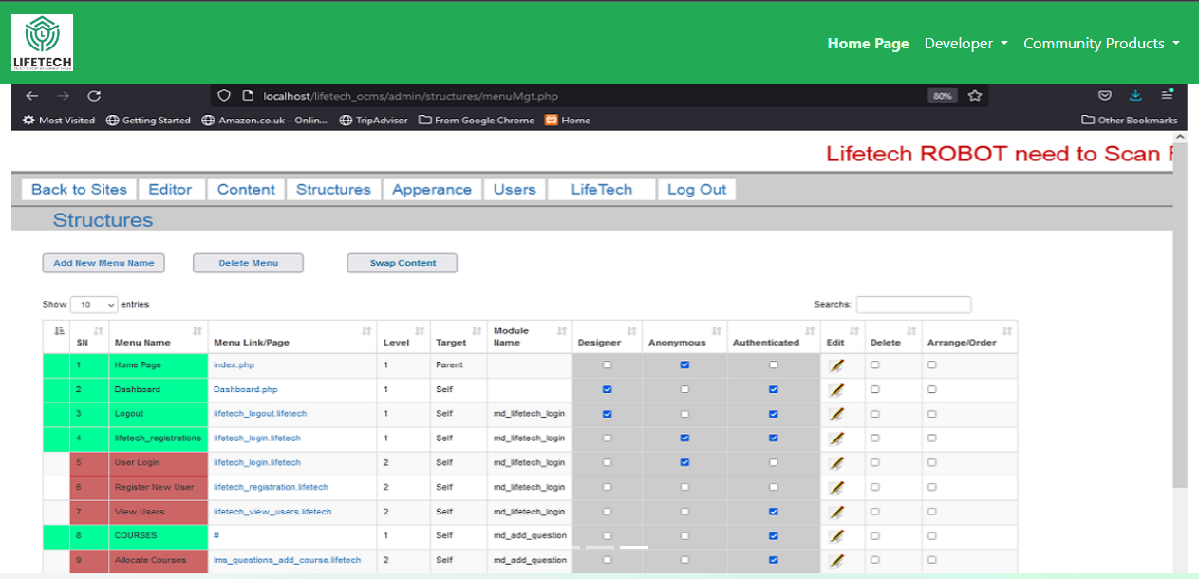

Figure 1: Lifetech OCMS picture

# WORK DONE WITH WORDPRESS

## OVERVIEW OF WORDPRESS

WordPress is an immensely popular and versatile Content Management System (CMS) that empowers users to create, manage, and customize websites and blogs with remarkable ease and flexibility. With a rich history dating back to its initial release in 2003, WordPress has evolved into a robust platform that drives a significant portion of the websites on the internet today. (Kinsta, 2023)

## FEATURES OF WORDPRESS

1. **Open-Source Foundation:** WordPress is open-source software, which means it's freely available to anyone and can be modified, extended, and redistributed without restrictions. This open-source nature has fostered a thriving global community of developers, designers, and users who continually contribute to its growth.
2. **User-Friendly Interface:** One of WordPress's key strengths is its user-friendly interface, making it accessible to individuals with varying technical backgrounds. The intuitive dashboard simplifies content creation, allowing users to add and edit text, images, videos, and other media effortlessly.
3. **Versatile Content Creation:** WordPress is renowned for its blogging capabilities, but it's not limited to just blogs. It can be used to create a wide range of websites, including personal blogs, corporate websites, e-commerce platforms, portfolios, forums, and more. Content can be organized using categories and tags, making it easy to navigate and search.
4. **Themes and Customization**: WordPress offers an extensive library of themes, both free and premium, that determine a website's appearance and layout. Users can customize themes to match their brand or style preferences, and developers can create their themes for even greater control. A powerful theme customizer allows real-time previews of design changes.
5. **Plugins and Extensibility:** The availability of plugins is a defining feature of WordPress. These extensions enhance functionality and can add almost any feature or capability imaginable. There are thousands of free and premium plugins available in the official WordPress Plugin Repository.
6. **SEO-Friendly**: WordPress is inherently search engine-friendly, with clean and structured code that facilitates better indexing by search engines. Numerous SEO plugins, like Yoast SEO, provide additional tools for optimizing content and improving search rankings.
7. **Security Measures:** WordPress takes security seriously and regularly releases updates to address vulnerabilities. Users can bolster security further through best practices, such as strong passwords, regular backups, and the use of security plugins.

In summary, WordPress's enduring popularity is a testament to its versatility, user-friendliness, and adaptability. Whether you're a beginner or an experienced developer, WordPress provides the tools and resources to create virtually any type of website or blog, making it a cornerstone of the internet's web development landscape.

## MY APPLICATION OF WORDPRESS

### I BUILT AN E-COMMERCE STORE WITH WORDPRESS

I successfully developed an e-commerce store using WordPress, demonstrating my proficiency in web development. This project involved tasks such as domain setup, WordPress installation, theme customization, plugin integration, product catalog creation, payment gateway setup, and optimization for search engines. The website was launched successfully, showcasing my ability to create a functional and visually appealing e-commerce platform. This experience allowed me to gain valuable insights and expertise in WordPress development, contributing to my skill set and highlighting my ability to create a robust online shopping experience.

### 3.3.2 STEPS INVOLVED IN PROJECT EXECUTION

1. **Domain and Hosting Setup**: I initiated the project by securing a domain and hosting, ensuring a solid foundation for our WordPress e-commerce store.
2. **WordPress Installation and Configuration:** I smoothly installed WordPress and configured it to meet our e-commerce needs, ensuring a solid foundation for our website.
3. **Theme Selection and Customization**: I selected and customized a theme, tailoring our WordPress site's appearance and functionality to align with our e-commerce requirements.
4. **Plugin Installation and Integration:** I adeptly installed and seamlessly integrated essential plugins, enhancing our WordPress e-commerce store's functionality and user experience.
5. **Product Catalog Setup**: I meticulously organized and configured our product catalog, ensuring a user-friendly and efficient presentation of items on our WordPress e-commerce store.
6. **Payment Gateway Integration:** I expertly integrated secure payment gateways, enabling smooth and secure transactions on our WordPress e-commerce platform.
7. **Design and User Experience (UX):** I focused on design and user experience (UX), creating an appealing, intuitive interface for our WordPress e-commerce store.
8. **SEO Optimization:** I optimized our WordPress e-commerce store for SEO, enhancing its visibility and search engine performance to attract more potential customers.
9. **Testing and Quality Assurance:** I rigorously conducted testing and quality assurance measures to ensure the flawless functionality and user experience of our WordPress e-commerce store.
10. **Launch and Post-launch Activities:** After meticulous preparations, we successfully launched our WordPress e-commerce store, followed by ongoing post-launch activities to ensure its continued success.

### I BUILT A DROPSHIPPING SITE WITH DROPAZZ

Dropshipping is a business model where you sell products online without physically stocking them. Instead, you purchase items from suppliers as customers place orders, and the suppliers handle shipping. Dropazz, as a software, streamlines this process: it helps build dropshipping websites, provides hosting, and automates the dropshipping, offering significant convenience.

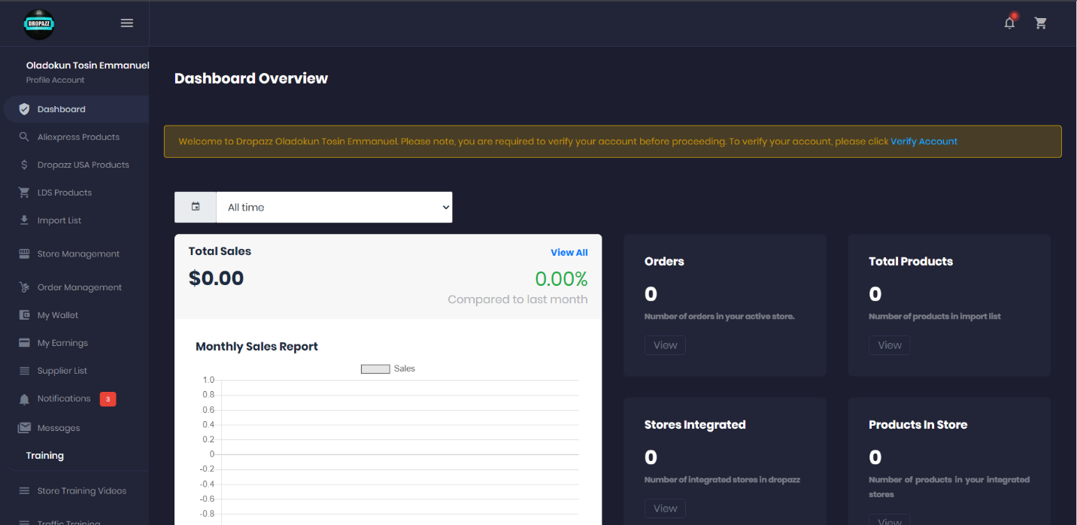

REFERENCES

BrainStation. (2023, October 10). *What is Web Development (2023 Guide)*. Retrieved from BrainStation: https://brainstation.io/career-guides/what-is-web-development

Clutch. (2023, October 10). *Talosmart Clients Reviews | Clutch.co*. Retrieved from Clutch.co: https://clutch.co/profile/talosmart#highlights

Lifetech. (2022, January 11). *Lifetech :: Community*. Retrieved from Lifetech: https://lifetech.host/hub/

VC4A. (2023, October 10). *Talosmart - VC4A*. Retrieved from VC4A: https://vc4a.com/ventures/talosmart/